**Module Title**

**Internet Technologies**

**Assessment Type**

**Portfolio Coursework**

Corse: Bsc (Hons) CS & DF

L3_sem-2

**Student Name: Osama Jat**

**UWE ID: 24030174**

**Assignment Submission Date:26-6-2024**

**Week: 7**

Exercise-1

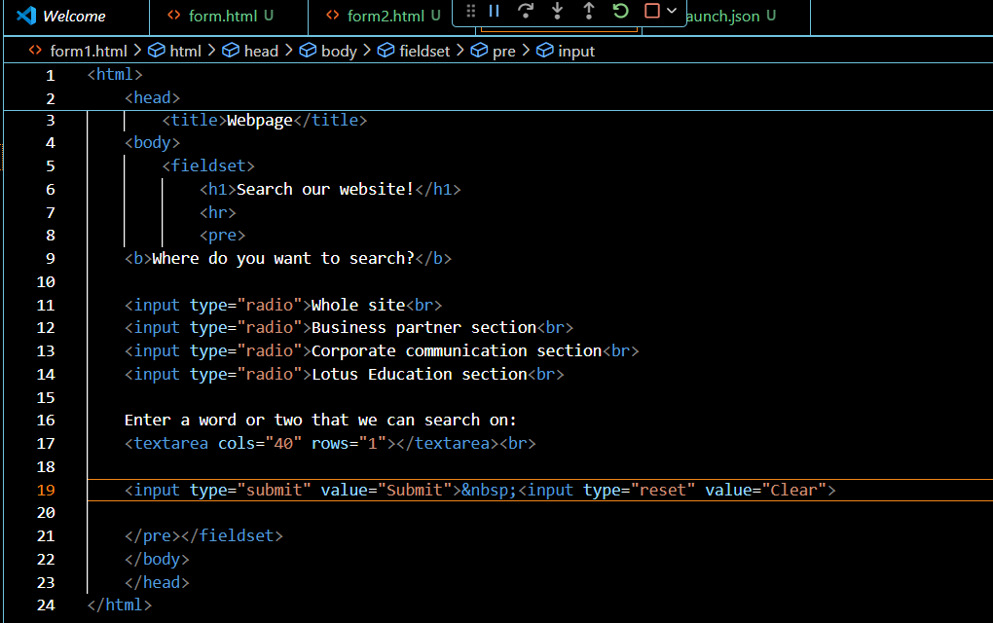

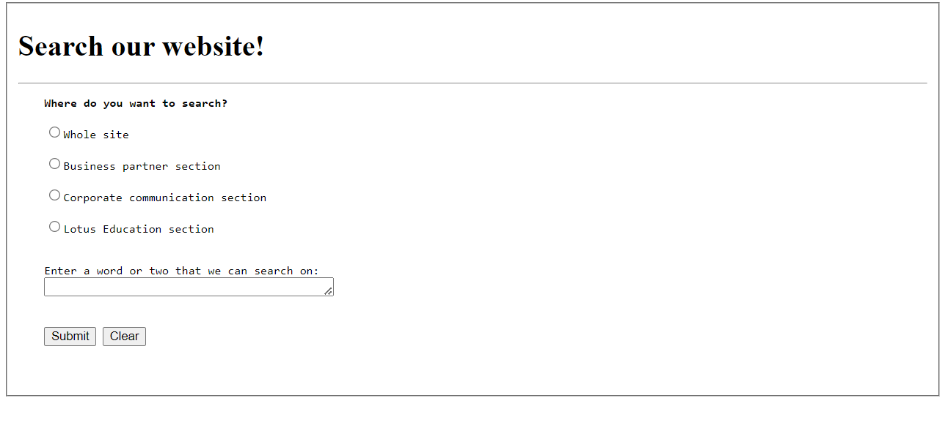  
  
  
  
  
  
  
  
  
  
  
  
  
  
  
  
  
  
  
  
  
  
  
  
  
  
  
  
Exercise-2

